Approving Time Quick Reference Guide
Last Updated: 11/13/2023
This guide outlines the process for interpreting and approving employee Time Sheets within SuccessFactors. This document is for use by supervisors of employees who record time using the Negative or Positive entry methods in SuccessFactors.

Negative Duration Entry: Employees assigned this entry method only record exceptions to their working time, according to their schedule. (Examples: Overtime). Each time an exception is recorded, it flows to their supervisor/manager for approval. Employees are instructed to complete all time entries/exceptions directly following their final shift of each week.

Positive Duration Entry: Employees assigned this entry method record the number of hours they worked each working day. Employees are instructed to submit all Time Sheets directly following their final shift of each week. Time Sheets in SuccessFactors are in a one-week format. This means for each bi-weekly pay period, supervisors will approve two Time Sheets per employee.
- Supervisor Approvals are due at 10:00 AM on the Monday following the end of each pay period.
- After 10:00 AM on Monday, all time sheets are pushed to Payroll for payment. Time sheets or exceptions that are not approved by a supervisor will remain in the supervisor’s approval queue, will appear on the Delinquent Supervisor Approval report, and will require supervisor approval ASAP (even after payroll has been processed).
- Supervisors have access to run the report SuccessFactors Time Details Report for Managers. This report displays Time and Time Off data and should be used to identify issues and identify actions needed in SuccessFactors by the supervisor or initiate conversations with employees to resolve issues prior to the payroll deadline.

Contents
Accessing SuccessFactors 1
Note for Supervisors with Multiple Appointments 1
Approving Time Exceptions / Timesheets 1
Reading and Approving the Timesheet 2
Viewing an Employee’s Time Sheet Outside of Approval Process or Editing Time Sheet 3

Accessing SuccessFactors
Access Employee Launchpad SuccessFactors.  Log in with your User ID and Password. |  | https://one.purdue.edu/

Note for Supervisors with Multiple Appointments
Supervisors with more than one appointment will have to switch to other account(s) to view pending actions that fall under those appointments by clicking the Change Selected Employment icon on the Navigation bar.

Approving Time Exceptions / Timesheets
Time Sheets requiring approval appear under Approvals in individual or stacked tiles. This allows you to quickly approve from the tile or click the tile to view Workflow Details. Click View All to see the individual time sheets.

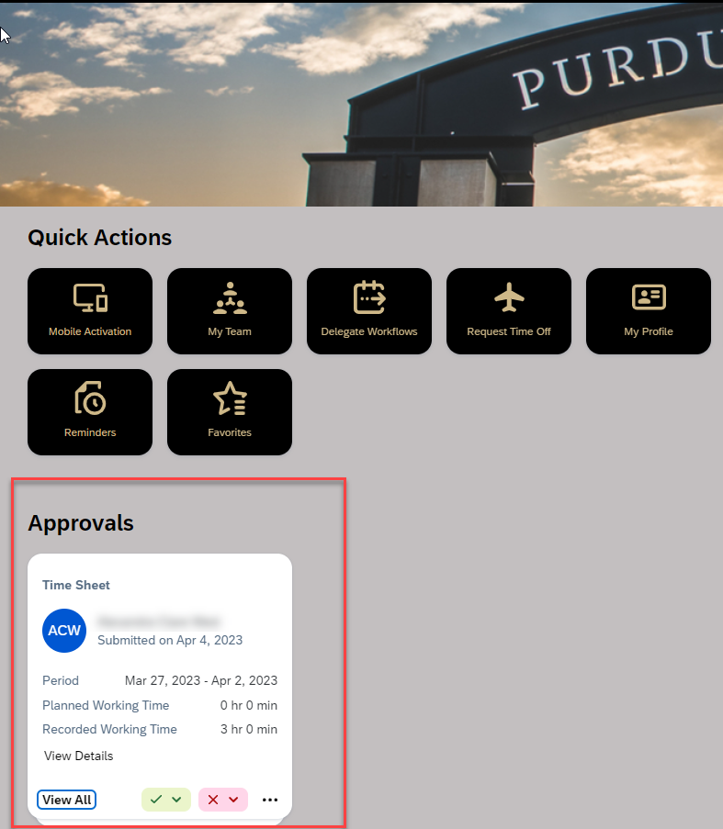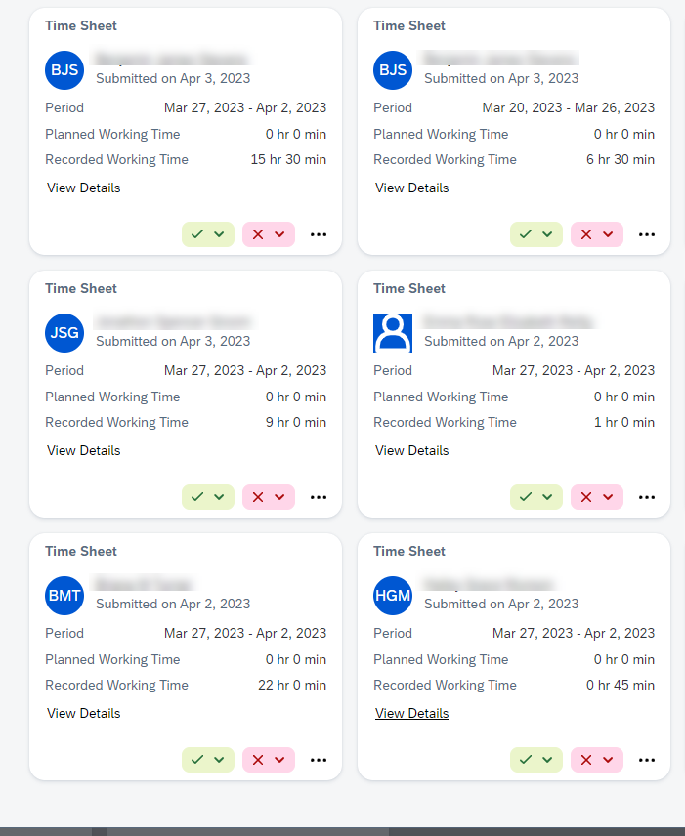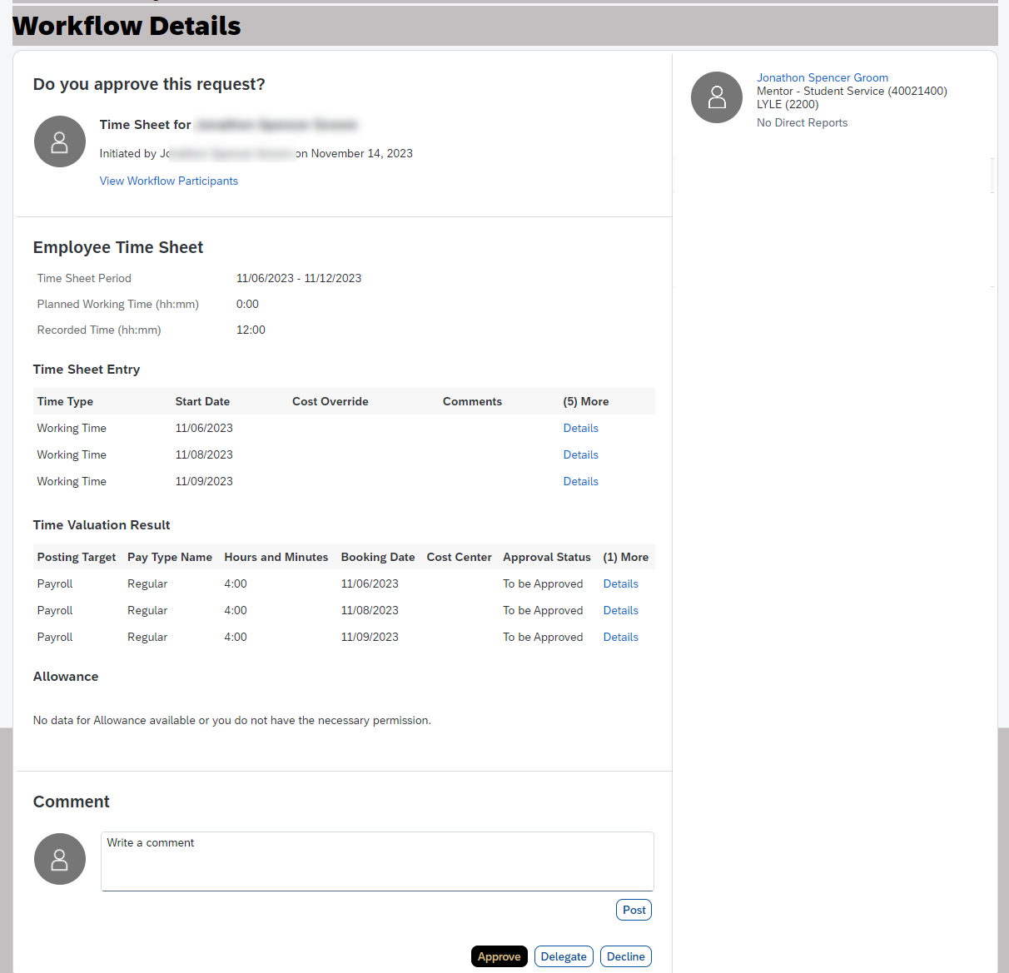

To view in list format. Click the icon to open the My Workflow Requests page.  Requests can be approved directly from this screen by clicking the green Approve button or click Select to select all and approve at once.  Click employee name to open Time Sheet. |  | 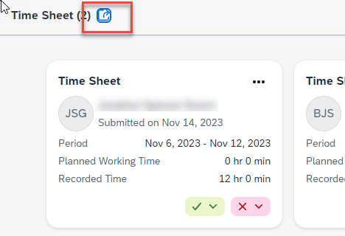  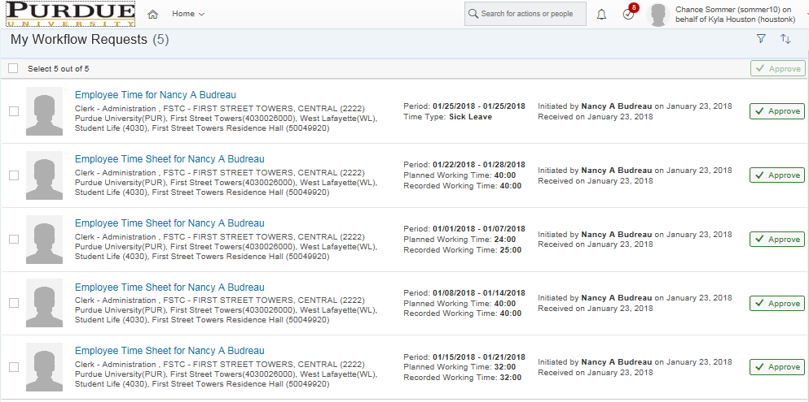
Planned Working Time: Reflects scheduled work time. Does not reflect holidays.  Recorded Working Time: Reflects recorded working time and leaves. |  | 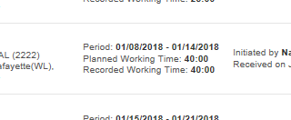

Reading and Approving the Timesheet
The timesheet is divided into two sections: Time Sheet Entry and Time Valuation Result.  Time Sheet Entry: Reflects all hours initiated by employee within their timesheet.  Time Valuation Result: Reflects all hours of all pay types recorded for the week. (Pay Types may include overtime, time off requests, etc.) |  | 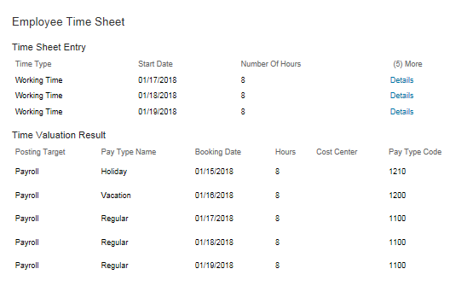
Supervisors should avoid editing employees’ timesheets except in instances where the employee is unavailable. A comment should be posted and the timesheet declined so that the employee can make the correction. If the employee is unavailable, supervisors may edit the timesheet. Only the employee can enter or adjust Time Off requests.
Approve, Delegate and Decline buttons are located at the bottom of the timesheet along with a comment box.
- To leave a comment on the timesheet, type the comment and click Post.
- Delegate provides the option to delegate the approval task to someone else. Once delegated, they receive notification and it will be in their approval section.
- Decline will notify the employee that the timesheet has been declined and needs to be edited and resubmitted.
- Approve routes the timesheet to be processed by payroll.

Viewing an Employee’s Time Sheet Outside of Approval Process or Editing Time Sheet
A supervisor can use these steps to view an employee’s timesheet at any time, whether there is a pending Approval Request or not.
On the SuccessFactors homepage, click the Manage My Team tile, then click the Employee Name (that you want to view the Time Sheet) - click Links - click Time Off
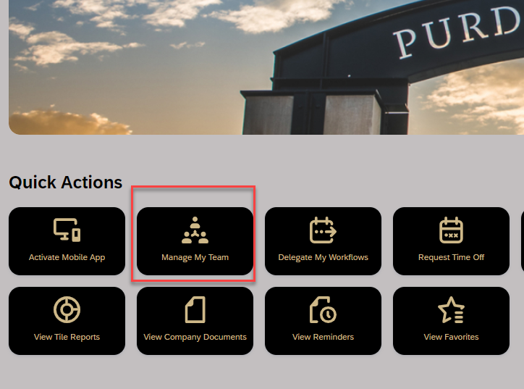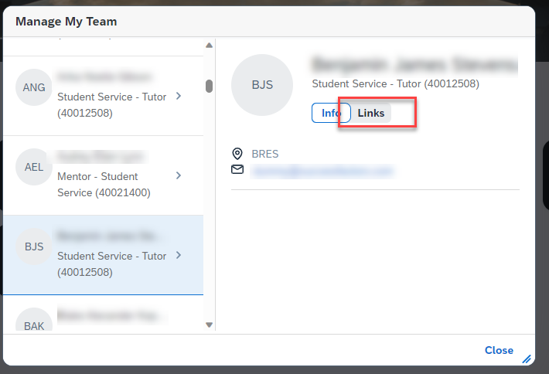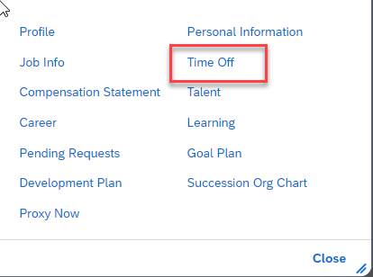
Click Go to Time Sheet | 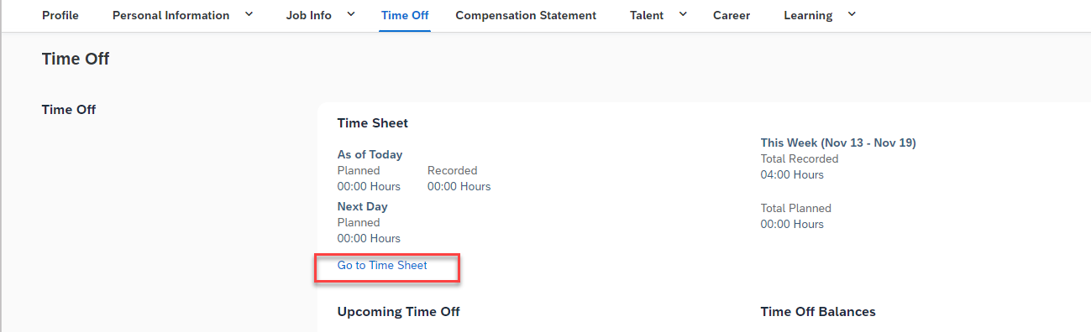
It will open current Time Sheet. Simply click day and then Record. Type total hours worked for Working Time and then Save.  - You may need to use the arrows to navigate to the week needing edited.  - If already approved, you may need to click Withdraw to edit and then Submit (and approve again). | 